NAME – AHMED HUSSAIN SHAIKH
EMP ID – TM01331
Step-by-Step Guide: Karpenter POC on EKS
Today, I’m going to walk you through Karpenter, an open-source node provisioning tool by AWS that helps optimize Kubernetes cluster resources by launching nodes dynamically based on pod requirements. We’ll cover its need, architecture, how it differs from the Cluster Autoscaler, and then I’ll walk you through a POC I did to see it in action.
What is Karpenter?
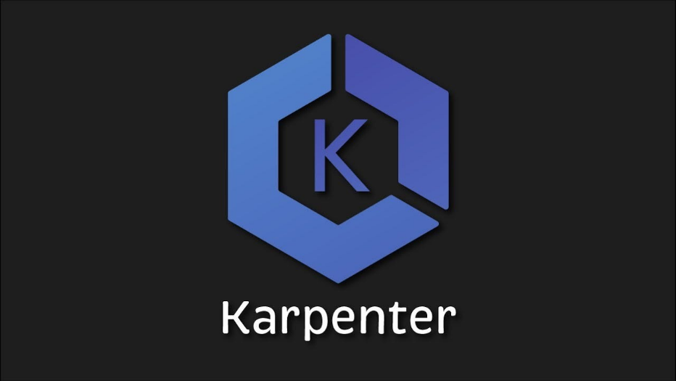
Karpenter is an open-source, dynamic node provisioning tool developed by AWS for Kubernetes. It is designed to automatically launch and terminate compute resources (EC2 instances) in real time, based on the needs of your workload — faster, smarter, and more cost-effective than the traditional Cluster Autoscaler.
Karpenter watches for unschedulable pods in your cluster and immediately responds by launching the best-fit EC2 instances to accommodate them, using the pod specifications like CPU, memory, and storage requirements.
How Karpenter Works – Step-by-Step
- A pod is deployed that requires resources that no existing node can satisfy.
- The Kubernetes scheduler marks the pod as unschedulable.
- Karpenter detects this unschedulable pod.
It evaluates:
- CPU/Memory/GPU requirements
Karpenter selects the most suitable instance type (e.g., t3.large, c5.xlarge), chooses the best availability zone, and launches the EC2 instance.
Note: Directly integrates with EC2 (uses the AWS API to launch instances) – Which means
- Karpenter directly talks to the EC2 API using AWS IAM permissions.
- It can launch any EC2 instance type (including On-Demand or Spot) without needing predefined node groups or Auto Scaling Groups (ASGs).
- It makes decisions in real-time based on pod needs and provisions instances without ASG overhead.
Unlike Cluster Autoscaler
- Cluster Autoscaler does not launch EC2 instances directly.
- Instead, it relies on predefined ASGs (Node Groups) created and managed either manually or via EKS.
- When it detects pending pods and resource shortage, it increases the desired capacity of an ASG.
- AWS Auto Scaling then takes care of launching EC2 instances.
Karpenter Architecture – Detailed Explanation
1. Karpenter Controller
A Kubernetes controller (like a Deployment) that watches for unschedulable pods.
Runs in the karpenter namespace.
Watches the Kubernetes API Server for events related to scheduling failures.
2. Provisioners
Custom Karpenter resource in Kubernetes.
Define how and when Karpenter can create nodes.
You use it to configure:
Allowed instance types (e.g., t3.medium, t3.large)
Availability Zones (e.g., us-east-1a, us-east-1b)
Node taints, labels, and other scheduling constraints
TTL for empty nodes (auto-termination after X seconds)
3. Cloud Provider Integration (IAM Role)
Karpenter needs permission to:
Describe, Create, and Terminate EC2 instance
Tag and associate instances with load balancers and other AWS services
You create an IAM Role for the Karpenter controller to assume using IRSA (IAM Roles for Service Accounts).
This allows Karpenter to securely interact with AWS APIs from within the cluster.
How It Works (Flow)
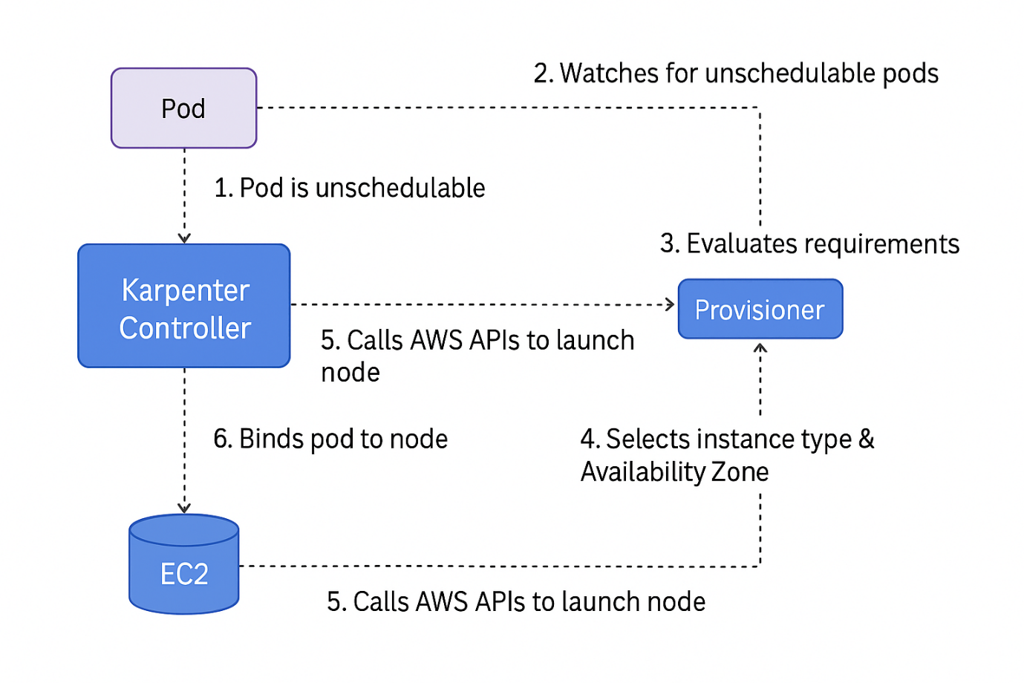
Let’s go through the full flow Karpenter follows when a pod is unschedulable:
Step 1: Pod is Unschedulable
A user or workload submits a pod that requests resources (e.g., 2 vCPUs, 4Gi memory).
No existing node in the cluster can satisfy these requests.
The pod enters Pending state.
Step 2: Karpenter Detects It
Karpenter continuously watches for pending pods using the Kubernetes API.
It sees that the pod cannot be scheduled by the default scheduler.
It queues the pod for evaluation.
Step 3: Evaluates Requirements
Karpenter reads the pod spec to determine:
CPU and memory requests
Tolerations, node selectors
Karpenter checks the active Provisioner and AWSNodeTemplate to match rules.
It determines the best instance type and zone to launch the pod.
Step 4: Interacts with AWS EC2 API
Karpenter uses the IAM role to call the AWS API.
It picks the optimal EC2 instance type based on pricing, performance, and availability (may prioritize Spot instances if configured).
It calls RunInstances API to launch the new EC2 node with:
Correct subnet
Security groups
Step 5: New Node Joins the Cluster
The new EC2 instance starts and runs the EKS worker node agent.
It automatically joins the Kubernetes cluster because of bootstrap configuration.
Karpenter labels and taints the node if required based on the provisioner
Step 6: Pod is Scheduled on New Node
Once the node joins and is ready, the default scheduler assigns the pending pod to the new node.
The pod is now running, and resource demand is satisfied dynamically.
Why Use Karpenter? – Key
1. Faster Scaling
Karpenter doesn’t rely on ASGs.
It talks directly to the EC2 API, provisioning new nodes in seconds, not minutes
Real-world impact: Your application can react to burst traffic much faster
2. Right-Sized Nodes
Chooses the most cost-efficient instance type (e.g., based on vCPU, memory, region, price).
Cluster Autoscaler uses pre-defined instance types only — less flexible.
3. Improved Cost Efficiency
Supports Spot Instances natively.
Automatically falls back to On-Demand when no Spot instances are available.
Schedules multiple pods per node, reducing overall EC2 footprint.
4. Intelligent Consolidation
Automatically removes under-utilized or idle nodes (via TTLs or consolidation policies).
Frees up budget while maintaining application availability.
Prerequisites:
- EKS cluster running
- IAM OIDC provider enabled
- kubectl, helm, eksctl installed
In our project Cluster Autoscaler was already applied to our node group, So in order to use only Karpenter I will disable the cluster autoscaler in this ng.
To do this now I will be removing the tags of cluster autoscaler from the agent processing node group.
To Disable Cluster Autoscaler for Your agent-processing Node Group:
Go to the EC2 Console → Auto Scaling Groups → Select the node group used for agent-processing.
Remove These Tags from That Node Group:
k8s.io/cluster-autoscaler/enabled true (or any value)
k8s.io/cluster-autoscaler/DSEKSCluster owned (or any value)
I have only done this, so now for testing after deploying kapenter anything goes wrong we can just delete the Karpenter deployment and add these tags to asg of node group agent processing and it will run.
Once you remove these two tags, Cluster Autoscaler will no longer detect or manage that node group. The other node groups that still have these tags will remain managed by the autoscaler.
Youtube reference - https://youtu.be/fx99gyMw1uk?si=z1vzUOL-Kxk5z7u2
Karpenter doc - https://karpenter.sh/v1.4/getting-started/migrating-from-cas/
Now before installing Karpenter we first need to create two new IAM roles for nodes provisioned with Karpenter and the Karpenter controller.
For Karpenter Node role we need to add policies such as
- AmazonEKSWorkerNodePolicy
- AmazonEKS_CNI_Policy
- AmazonEC2ContainerRegistryPullOnly
- AmazonSSMManagedInstanceCore

1. Karpenter Node Role
Role Name: KarpenterNodeRole-${CLUSTER_NAME}
Used By: EC2 instances (i.e., worker nodes) provisioned by Karpenter
🔐 Why this role is needed:
This is the IAM instance profile role attached to EC2 nodes launched by Karpenter.
It allows EC2 instances (nodes) to:
Connect to EKS (AmazonEKSWorkerNodePolicy)
Use CNI networking (AmazonEKS_CNI_Policy)
Pull images from ECR (AmazonEC2ContainerRegistryPullOnly)
Interact with SSM (AmazonSSMManagedInstanceCore) — helpful for things like connecting via SSM Session Manager
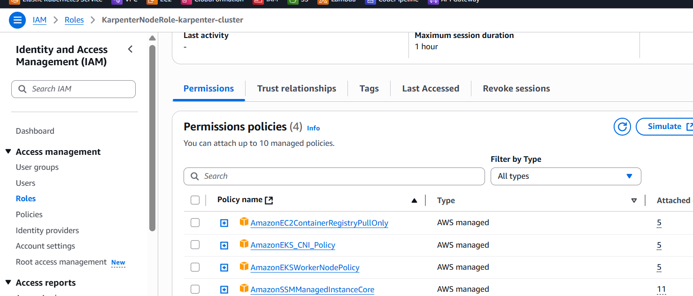
we need to create an IAM role that the Karpenter controller will use to provision new instances.
Role Name: KarpenterControllerRole-${CLUSTER_NAME}
Used By: Karpenter controller (a Kubernetes pod/service account running inside the cluster)
🔐 Why this role is needed:
- This role is assumed by the Karpenter controller running in the EKS cluster (via IRSA - IAM Roles for Service Accounts).
- It allows the controller to manage AWS resources on your behalf, such as:
  - Launching EC2 instances (nodes)
  - Reading EC2 and pricing metadata (e.g., instance types, spot pricing)
  - Managing EC2 Launch Templates and Instance Profiles
  - Describing the EKS cluster
  - Terminating EC2 instances when they are no longer needed
  - Tagging resources appropriately
  - Using the PassRole permission to assign the node role (KarpenterNodeRole) to the EC2 instances it launches

For policies – visit the karpenter doc
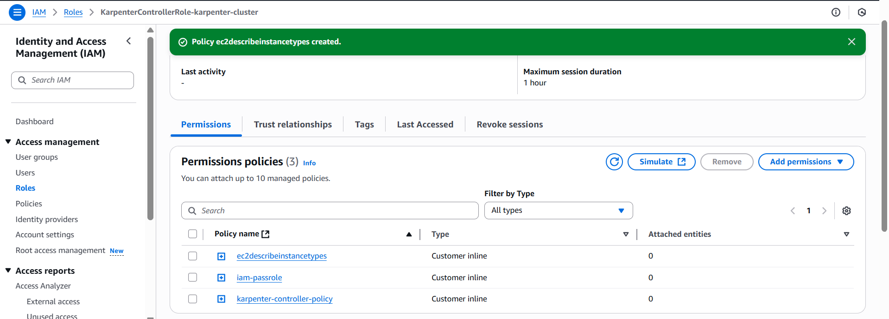
Add tags to subnets and security groups
We need to add tags to our nodegroup subnets and security groups so Karpenter will know which subnets and security group to use.
Key=karpenter.sh/discovery,Value=${CLUSTER_NAME}

install helm
and deploy the Karpenter - https://helm.sh/docs/intro/install/
Once helm is installed we will add the Karpenter version, and run the below helm command
export KARPENTER_VERSION="1.4.0"

helm install karpenter oci://public.ecr.aws/karpenter/karpenter --version "${KARPENTER_VERSION}" --namespace "karpenter" \
--set "settings.clusterName=EKSCluster" \
--set "settings.interruptionQueue=EKSCluster" \
--set "serviceAccount.annotations.eks\.amazonaws\.com/role-arn=arn:aws:iam::123456789101:role/KarpenterControllerRole-EKSCluster" \
--set controller.resources.requests.cpu=1 \
--set controller.resources.requests.memory=1Gi \
--set controller.resources.limits.cpu=1 \
--set controller.resources.limits.memory=1Gi
After doing all these things you can see our Karpenter is up and running.
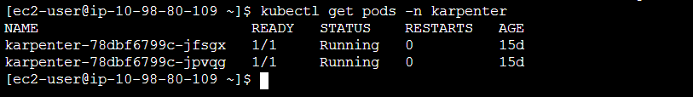
I deployed the nginx with 50 replicas where some of them went in pending state, so now also the autoscaling will not happen reason we have to create a node pool first.
kubectl create deploy nginx --image nginx --replicas 20
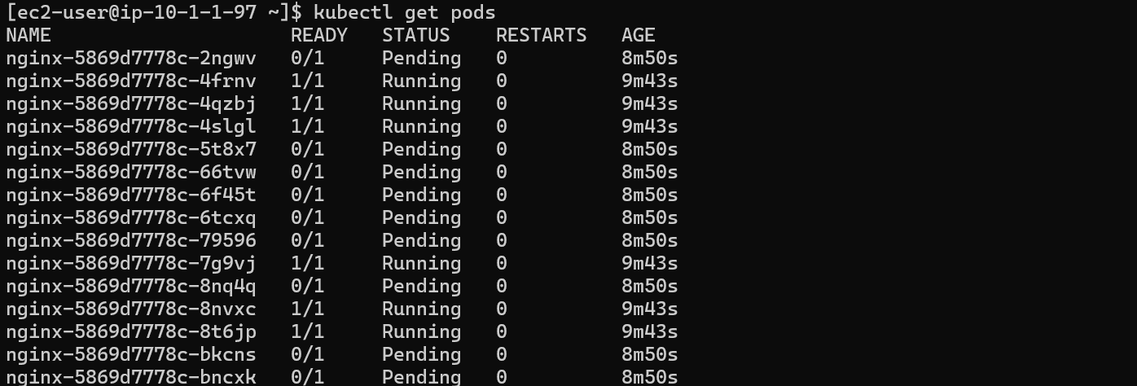
We create a nodepool
Nodepool.yaml
---
apiVersion: karpenter.sh/v1
kind: NodePool
metadata:
name: general-purpose
annotations:
kubernetes.io/description: "General purpose NodePool for generic workloads"
spec:
template:
spec:
requirements:
- key: kubernetes.io/arch
operator: In
values: ["amd64"]
- key: kubernetes.io/os
operator: In
values: ["linux"]
- key: karpenter.sh/capacity-type
operator: In
values: ["spot"]
- key: karpenter.k8s.aws/instance-category
operator: In
values: ["t", "m"]
- key: karpenter.k8s.aws/instance-generation
operator: Gt
values: ["2"]
nodeClassRef:
group: karpenter.k8s.aws
kind: EC2NodeClass
name: default
---
apiVersion: karpenter.k8s.aws/v1
kind: EC2NodeClass
metadata:
name: default
annotations:
kubernetes.io/description: "General purpose EC2NodeClass for running Amazon Linux 2 nodes"
spec:
role: "KarpenterNodeRole-karpenter-cluster" # replace with your cluster name
subnetSelectorTerms:
- tags:
karpenter.sh/discovery: "karpenter-cluster" # replace with your cluster name
securityGroupSelectorTerms:
- tags:
karpenter.sh/discovery: "karpenter-cluster" # replace with your cluster name
amiSelectorTerms:
- alias: al2023@latest # Amazon Linux 2023
And saw that in ec2 console ec2 is getting scaled

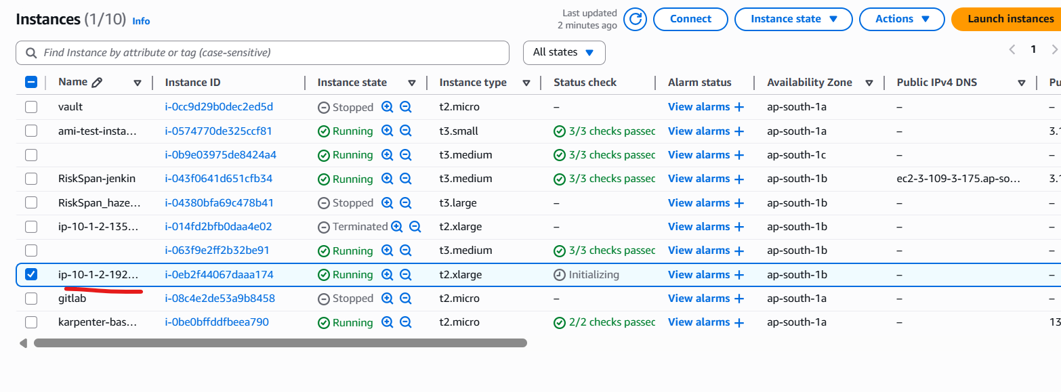
But it will not get attached to kubernetes cluster reason we have to add access in kubernetes cluster of our karpenter node role there.
After adding we can see that the the pods are getting in running state.
